ENGR36035D

Introduction to Energy Systems

Professor: Amin Ghobeity, Ph.D., P.Eng.
Consultation Hours: (Office Hours: Thursdays 2:00-3:00pm with appointment)

EVALUATION PLAN

The dates and activities indicated below are subject to changes or modifications due to unforeseen circumstances. Any changes to this plan will be announced in class or via SLATE.
Students demonstrate their learning in the following ways:

      - Laboratory Assignments (3@ 5%) 15%
      - In-classroom Assignments (3@ 5%) 15%
      - Project (Report and Presentation) 15%
      - Midterm Exam 25%
      - Final Exam 30%
Total 100%

COURSE MATERIALS AND OUTLINE

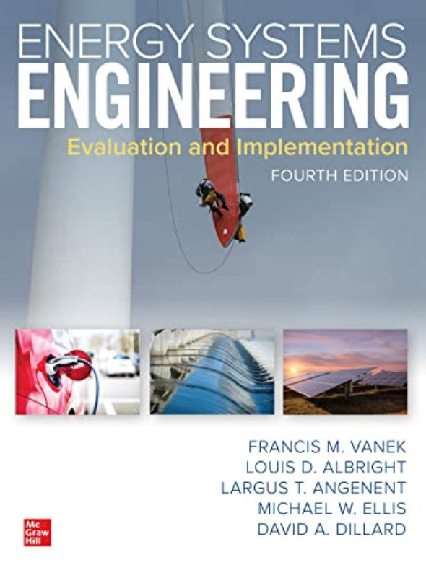
The textbook used for the course is:

Energy Systems Engineering: Evaluation and Implementation, Fourth Edition

Other resources:
Alternative Energy Systems
by B.K. Hodge
Energy, Environment, and Sustainability
by S. Moaveni

COURSE LEARNING OUTCOMES

Learning Outcomes: To achieve the critical performance, students will have demonstrated the ability to:
- Interpret the environmental impact of current energy technologies.
- Analyze the environmental impact of energy systems including the modeling of anthropomorphic climate change.
- Develop energy system diagrams highlighting the main components of energy conversion systems.
- Estimate the future availability of non-renewable energy resources.
- Describe the operating principles of conventional power plants.
- Explain the thermodynamic cycles and working principles of various combustion cycle
- Analyze conventional power plant thermodynamic cycles.
- Describe the operating principles of non-conventional energy conversion technologies such as solar, wind, ocean, nuclear and fuel cell technologies.
- Analyze the resource requirements of non-conventional energy technologies.
- Develop system-level analytical models for energy systems.
- Develop computer simulation models for simplified energy systems.

Topical Outline

Module | Topic | Readings
1 | Introduction to Energy Issues | Chapter 1,2,3 Vanek
2 | Fuel in Energy Systems | Chapter 4 Vanek
3 | Combustion Cycles of Power Plants | Chapter 5 Vanek
4 | Climate Change Issues | Chapter 3 Vanek
5 | Introduction to Alternative Energy Sources | Misc. Chapters from Vanek and Hodge
6 | Modeling and Simulation of Energy Systems | Instructor Notes

Tentative Weekly Plan

Week # | Lecture Topics | Evaluation | Engineering Tools
1 | Introductory Energy Issues
2 | Introductory Energy Issues
3 | Modeling and Simulation of Energy Systems | In-classroom Assignment 1
4 | Modeling and Simulation of Energy Systems | Lab 1 | Standard Measurement Tools
5 | Combustion Cycles of Power Plants (Steam power plants) | In-classroom Assignment 2 | Macro-enabled Excel for Simulation and Energy Balance Calculation of Combustion Cycles
6 | Combustion Cycles of Power Plants (Gas Power Plants) | Projects Assigned
7 | MIDTERM EXAM Tuesday October 14th
8 | READING WEEK – NO CLASSES
9 | Climate Change
10 | Modeling of Climate Change | Lab 2 | MATLAB  Standard Measurement Tools
11 | Introduction to Alternative Energy Systems – Nuclear Power | In-classroom Assignment 3 | System Advisor Model (SAM) - Software Package for simulation of energy systems  Standard Measurement Tools
12 | Introduction to Alternative Energy Systems – Solar Thermal | Lab 3
13 | Introduction to Alternative Energy Systems – Solar Photovoltaics | Project Reports & Presentations Due
14 | Introduction to Alternative Energy Systems – Wind Power
15 | FINAL EXAM DATE AND TIME TO BE CONFIRMED BY THE SCHOOL

